**OPT SOP**

**Technical Authors & Contributors**

|  |  |
| --- | --- |
| **Department** | **Name** |
| Imaging | Rusty Nicovich, Mike Taormina , Nhan-Kiet Ngo |
| Structured Science |  |

**Date of SOP Creation (Version 1.0):** 7/1/2019

**Periodic Review**

|  |
| --- |
| Biannual  Annual  Biennial  None Last Review: 7/1/2019 |

**Departmental Sign-Off**

|  |  |  |  |
| --- | --- | --- | --- |
| **Department** | **Approval**  **Required** | **SOP**  **Reviewed** | **Name** |
| Imaging |  |  | Rusty Nicovich |
| Engineering |  |  |  |
| Health and Safety |  |  |  |
| Scientific Lead |  |  |  |

1. **Scope:** This protocol describes the imaging and image processing of OPT.
2. **Materials:**
   1. Specially cleared mouse brain specimens.
   2. Loctite 404 superglue.
   3. Stainless steel circular mounting disks.
   4. Kimwipes.
   5. Tweezers.
   6. Solid waste bag.
   7. Dibenzyl ether.
   8. Razor blade.
   9. 100% ethanol.
3. **Equipment:**
   1. OPT imaging platform.
   2. Processing computer.
   3. External hard drive.
4. **Safety:** 
   1. Nitrile Gloves.
   2. Lab coat**.**
5. **Output:** Fully imaged whole mouse brain in white and fluorescent lights.
6. **Reference Documents:**
   1. **None.**
7. **Data Acquisition:**
   1. Press the power button on the OPT machine**.**
   2. Press the On/Off button
   3. Select Recall 2 to enable 18.0 V, < 1 A output on channel 2.
   4. Open Micro-Manager 2.0 on the computer and select the default options. Click Ok. See 7.4.1.
      1. 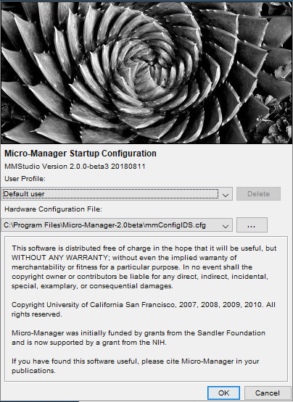
   5. Go to Tools 🡪 Script Panel 🡪 optacp.bsh.
      1. Create a storage folder in the following directory: D:\diyOPT\ and name the new folder using the following convention: xxxxyyzz where xxxx is the 4-digit year, yy is the 2-digit month, and zz is the 2-digit day.
      2. In optacp.bsh, baseFile = "" is the 6-digit specimen ID. Rename rootDirName = "D:/diyOPT/xxxxyyzz" to match the new folder just created. Then click "save". See 7.5.3 for example.
      3. 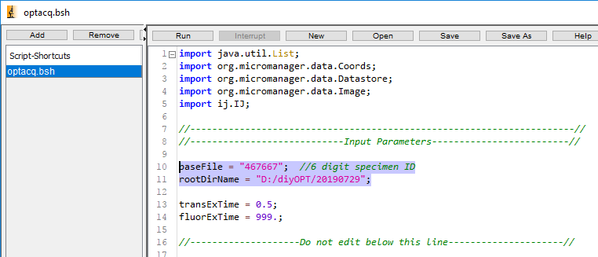
   6. Select a specimen to be imaged.
   7. Use a pair of tweezers to take the specimen out of its storage vial.
   8. Gently dab dry the specimen with Kimwipes.
   9. One small drop of Loctite 404 in the center of the mounting disk.
   10. Glue the cerebellum end of the specimen on to the disk. Wait at least one minute before using the tweezers to gently tap the specimen to make sure it's well glued.
   11. Mount the disk to the OPT imaging assembly.
   12. Center the disk and brain on the assembly. Tip : spin specimen with motor advance button on controller. At same time, use rounded object such as screwdriver handle to gently push disk to center brain on motor axis.
   13. Fill the imaging chamber with dibenzyl ether.
   14. Place the filled imaging chamber in the imaging area.
   15. Gently mount the imaging assembly into four post holders surrounding the filled imaging chamber. Make sure the amount of dibenzyl ether in chamber covers at least 1/3 of the specimen disk height but not completely submerge the disk. If there's any trapped air bubbles under the specimen disk, spin the mounting disk several times to get rid of them.
   16. Micro Manager control panel.
       1. 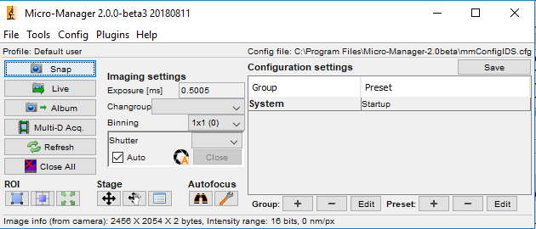
       2. In the Micro Manager control panel, click on Live. Turn the white light slide switch from TRIG to CW mode. White LED should now illuminate sample. In live view, determine the following:
          1. To determine the accurate exposure, adjust the light intensity (using LED controller knob) or exposure time (in MicroManager window) so that saturated hot spots just disappear and you have an even illuminating background without saturation. Using the limit-highlighting colormap is helpful here. See example of correct illumination in 7.15.2.2.
          2. 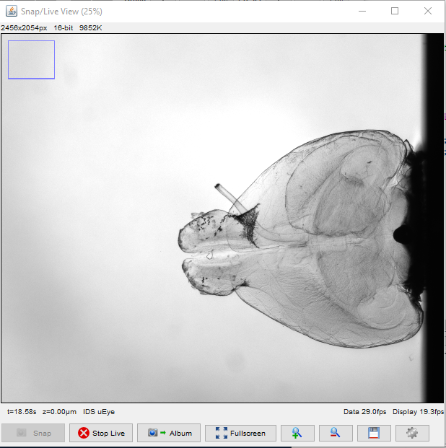
          3. The brain is well within the imaging area.
          4. Specimen is in focus.
          5. Use the stage micrometers to make any necessary adjustments to position and focus.
       3. Turn off live view (click ‘Stop Live’ in Micro Manager) and set white light controller to ‘TRIG’ position.
   17. Cover up the entire imaging platform with its box.
   18. After entering the 6-digit specimen ID in the optacq.bsh, click "Save" then "Run" in the script panel.
   19. The imaging process takes about six minutes to complete.
   20. Gently remove the imaging assembly from posts.
   21. Remove the mounting disk from the mechanism.
   22. Use razor blade safely and gently remove the brain from the disk.
   23. Use tweezers to place the specimen back into its original storage vial.
   24. Anything that comes directly in contact with dibenzyl ether needs to be throroughly cleaned by 100% ethanol. Solid waste goes into its storage bag.
   25. Use razor blade to remove any glue residue on the mounting disk.
   26. Store the specimens appropriately.
   27. Transfer the newly collected data to the processing station via the external hard drive.
8. **Data Processing.**
   1. On the processing computer, in D:\Data\diyOPT\ create a folder with exact same name as the data folder want to transfer over. This is the data storage folder.
   2. Open Spyder and script stackToPlanes.py. Set script variables to:
      1. inputFolder: Directory path of data folder from the external hard drive.
      2. outputFolder: Directory path of data folder created in 8.1. See example in 8.2.3
      3. 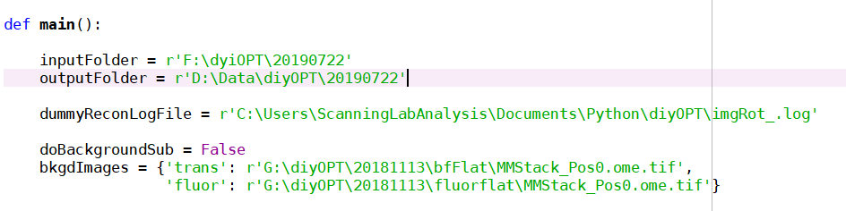
      4. Run stackToPlanes.py script in Python. Images and folders should be created in destination outputFolder designated in steps 8.1 and 8.2.3.
   3. Open Nrecon, then open specimen folder to be processed.
   4. Open the translucent (trans) folder first. Select the first image.
   5. Start tab:
      1. Position the green horizontal line at the specimen's widest section.
      2. Position the top horizontal line to be above speciemen's highest point.
      3. The value for bottom horizontal line is typically between 120 and 130.
      4. Record the values for Top and Bottom of range.
      5. Example: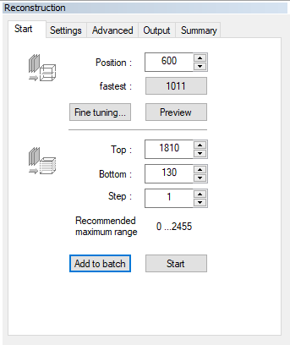
   6. Settings tab.
      1. Set Smoothing value to 3.
      2. Set Misalignment compensation value. This value is usually but not always, between -25 and -35. If the range is out side of -25 and -35, change the value until images align directly on top of each other. There should be no double images.
      3. Example: 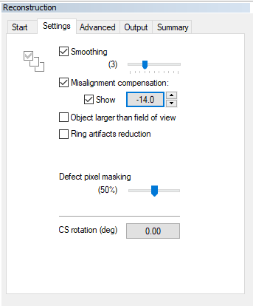
   7. Output tab.
      1. Uncheck Scales ON box.
      2. Destination: Browse and open the recon folder in the trans folder.
      3. File format: TIF(16).
      4. Example: 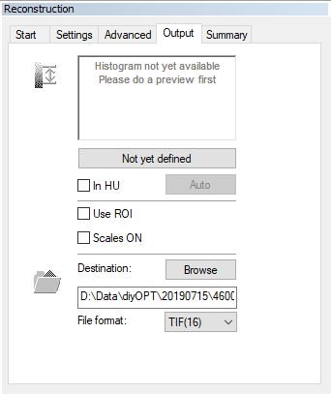
   8. Back to Start tab 🡪 Fine tuning 🡪 Number of trials = 10 trials 🡪 Start 🡪 Ok.
      1. Example: 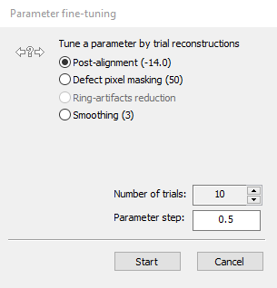
   9. After the trials are completed, in the Output tab, select the right vertical line and set all the way to the right of the histogram. Select the left vertical line and place it to the left of the base of the peak.
      1. Example: 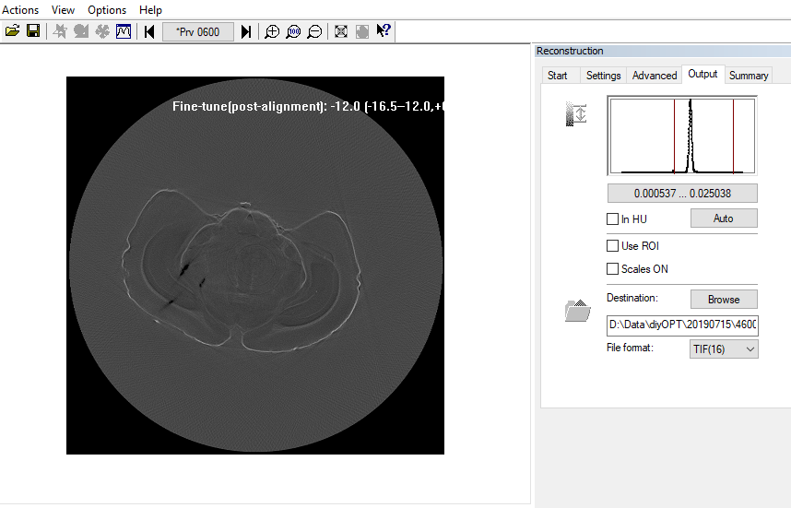
   10. Click on either the foward or backward arrow to determine the best- aligned image.
   11. Start tab 🡪 Add to batch.
   12. Open the fluorescent (fluor) folder of the same specimen. Select the first image, and repeat steps 8.5 – 8.9. For steps 8.5.1 – 8.5.4, enter the values for Top, Bottom, and Misalignment compensation you got from the transmitted channel. Make sure the destination is the recon folder inside the fluor folder.
   13. After completing all above steps for all specimens needed to be processed, go through the pending list to make sure all are 16-bit TIF.
   14. Start batch and let the processing runs overnight.
   15. Upon completion the next day, transfer data to the project's directory over the network.
9. **Takedown:**
   1. Clean work area. All items exposed to dibenzyl ether must be cleaned thoroughly by 100% ethanol.
   2. Store solid waste in its storage bag.
   3. Return the dibenzyl ether tub to the hood. Place a cover on it.
10. **Precautionary:** Dibenzyl ether is toxic. It's both storage and imaging medium. Wear PPE and exercise appropriate precautions.